Ohio Department of Transportation
Division of Information Technology

<InspectTech Laptop Collector>
Uninstallation User Manual
August 5, 2014
Ohio Department of Transportation
1980 W. BROAD ST., COLUMBUS, OHIO, USA 43223
Copyright © 2014, All rights reserved

How to Uninstall the Laptop App
- Open your computer’s Control Panel.
- Select Programs and Features > Uninstall a Program.
- Select InspectTech from the list (see 1).
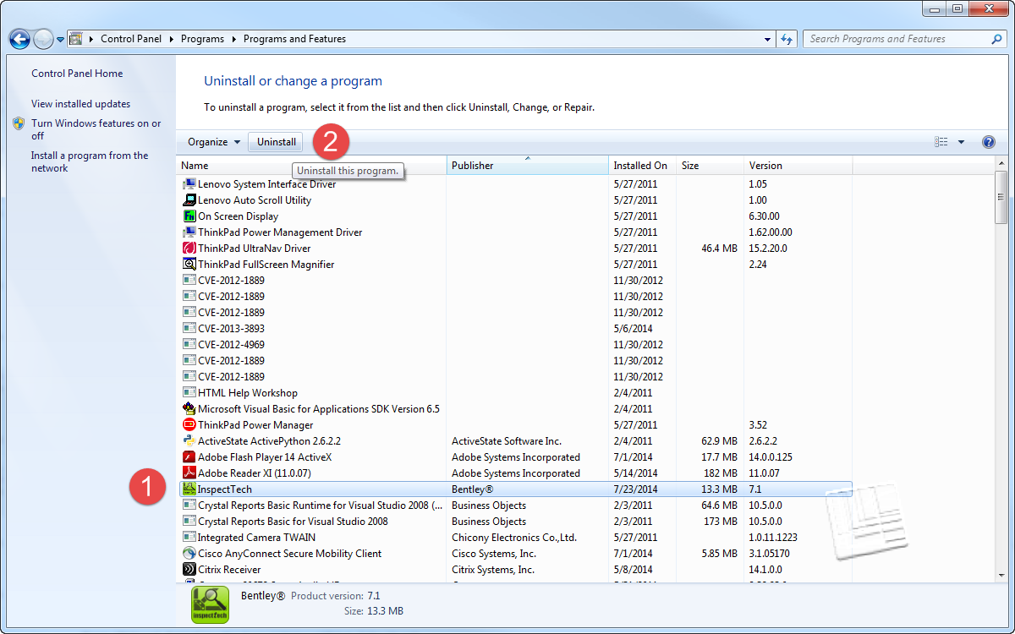

- Click Uninstall (see 2)
- When prompted, select Yes
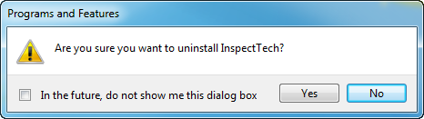

- Navigate to C:\ProgramData and delete the InspectTech directory. You go to drive C by clicking on the drive name below the Computer heading in the left column near the bottom. You might have to expand the Computer by clicking on the arrow to the left of the word. NOTE: The uninstall procedure may have deleted this folder so if you don’t see the Program Data folder directly under Drive C, you can go to the next step.
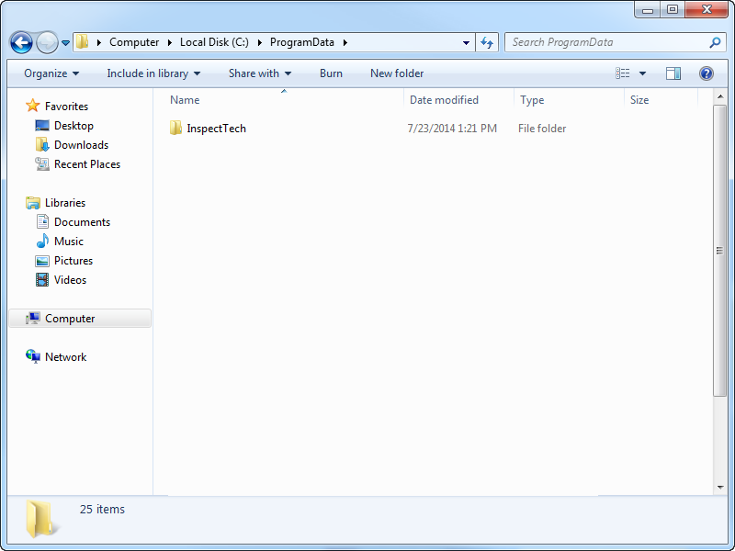

- Locate the provided Laptop Collector installation package by going to the ODOT ftp site and downloading the file titled ODOT Laptop Collector – Product.zip. It will could as much as 15 minutes to download the zip file. After the zip file is downloaded, double click on the ODOT Laptop Collector Product folder to open the following screen

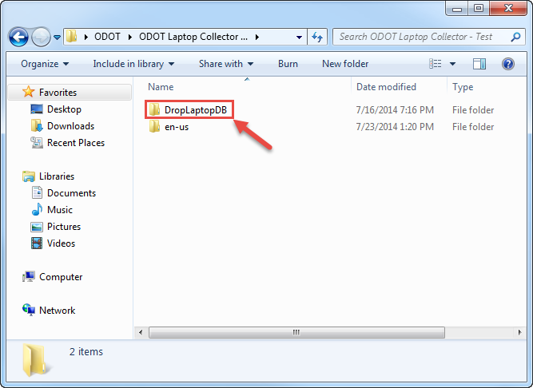
- Open the DropLaptopDB folder. If there is a second DropLaptopDB folder, open it as well.
- Double-click the drop_laptop_db application file. A new dialog will generate. You could see several screens about extracting files. Go ahead and extract all files when prompted. You could also see a message about the publisher could not be verified. Go ahead and run the file.
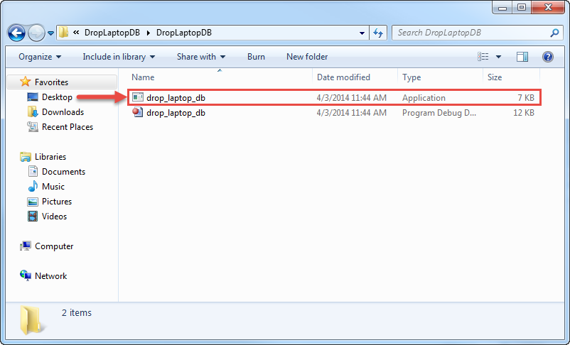

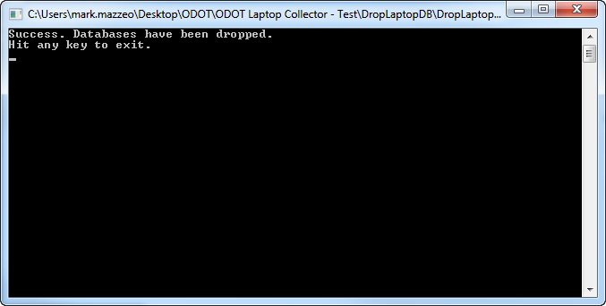

- Press any key to exit when prompted.

Note: If the initial installation never created a database for the laptop, you will receive an error after attempting to drop the laptop database. This is normal and you can proceed with the installation steps.

